**E-Fixed Deposits**

**Project Task on Business Analysis**

Q1) Identifying Stakeholders – Create a list of stakeholders (as taught in Business Analysis Planning and Monitoring Knowledge Area)

Ans) The list of the stakeholders of ABC Bank are as follows:

1. **ABC Bank Employees:** are those who are working in ABC Bank and has presence in 56 countries in the world
2. **ABC Customers:** are the bank users which go to the nearest bank branch for creation of fixed deposit
3. **ABC Bank Management:**  are the decision makers of the ABC Bank who has a future vision of 100% online bank and is planning to bring online FD in ABC Bank

Q2) Create As-Is and Future Process map (using flowcharts). You can use any of the popular tools in the market like Microsoft Visio, Lucid Chart, Creately, Pidoco, or Balsamiq

Ans) The flowchart of the existing ABC Bank is as follows:

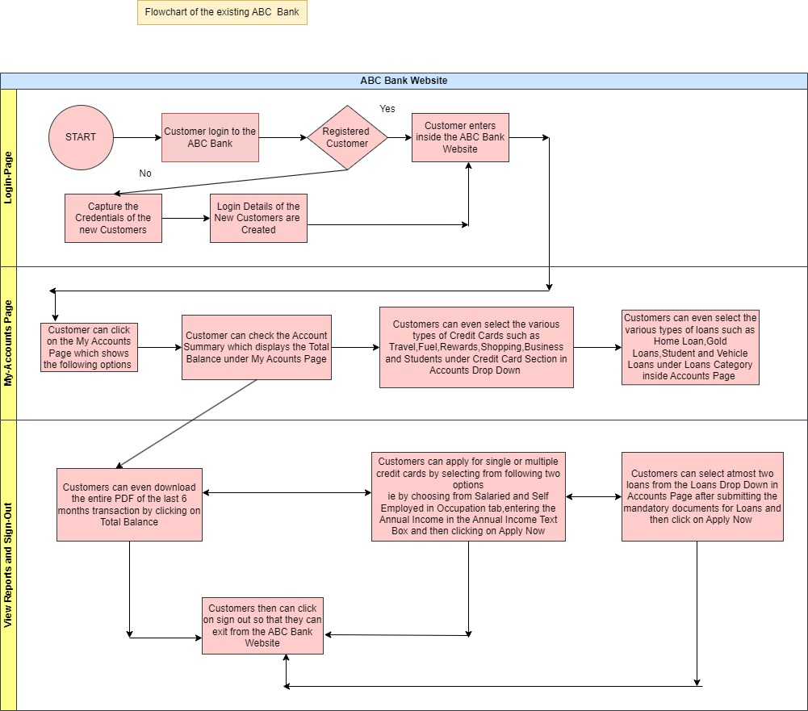

The above mentioned is the as-is Process Map of ABC Bank

The flowchart of new ABC Bank with E-Fixed Deposit is as follows:

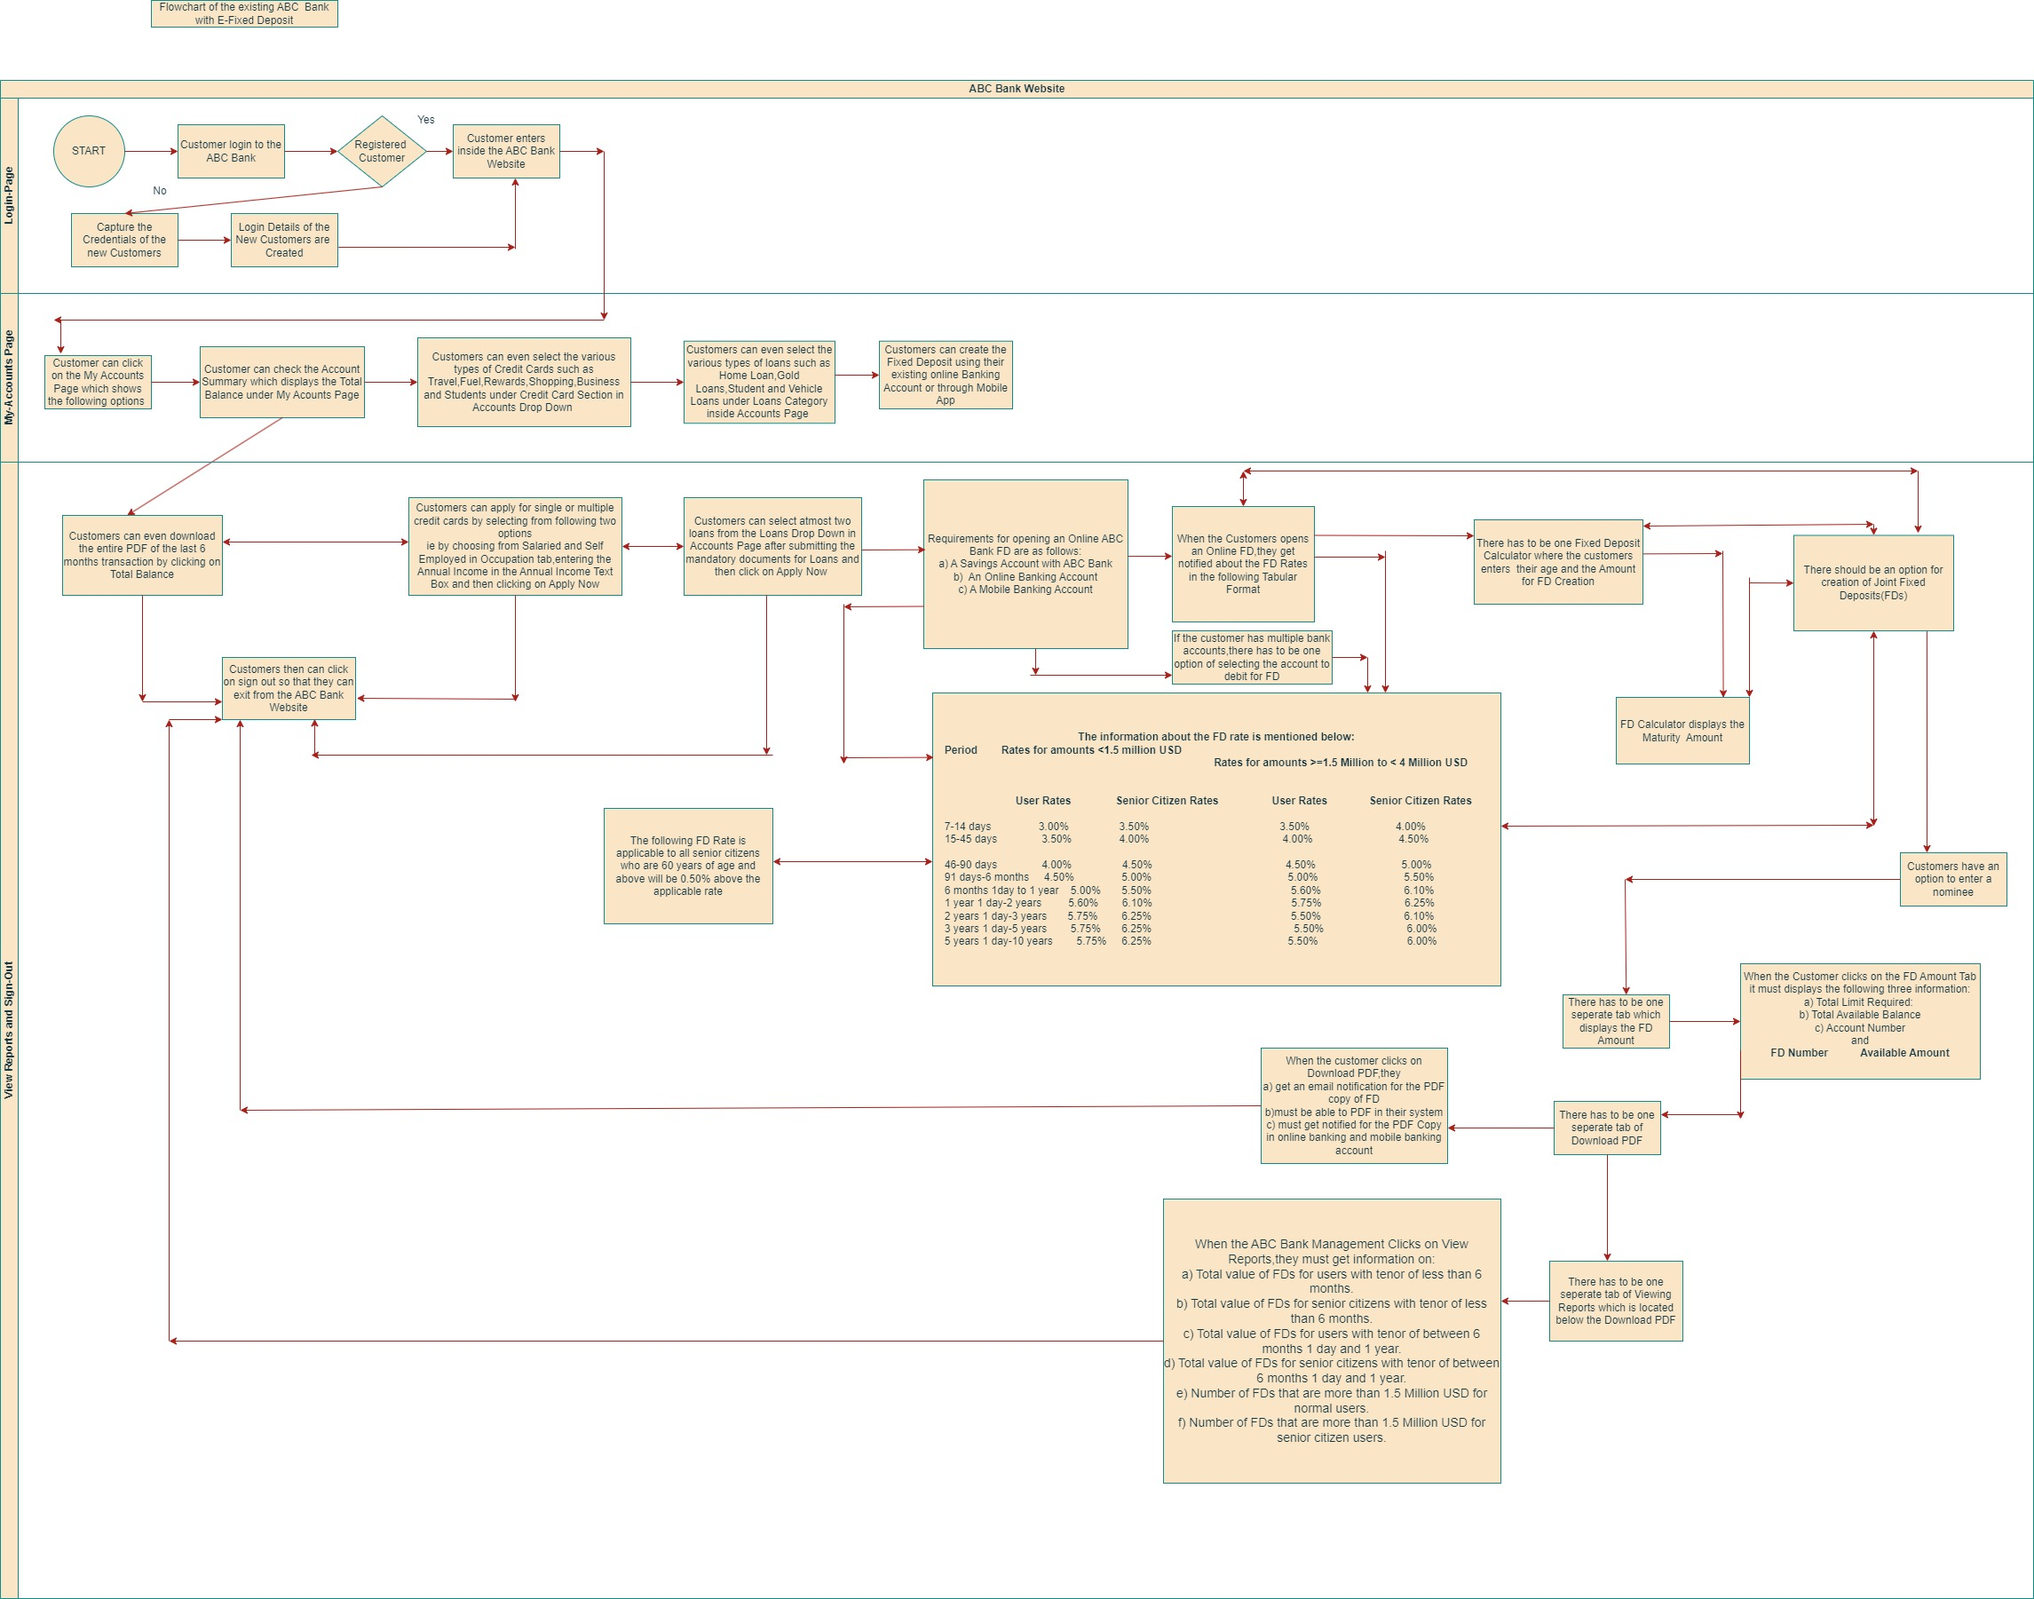

The above mentioned is the future process Map of ABC Bank with E-Fixed Deposit(Use Read Mode for Viewing the diagram)

Q3) As a Business Analyst working on this project, find out the scope of online FD creation. Write down the main features that need to be developed.

Ans) **Scope of the Online FD(Fixed Deposit) Creation**

Scope of the online FD Creation are the boundaries of the online FD.Scope Modelling is one of the acceptance criteria.Scope Modelling can be in-scope or out scope.

Examples of In-Scope of ABC Bank is mentioned below:

1. The ABC Bank has manual option for creation of Fixed Deposit
2. Customers visit the nearest ABC Bank for Fixed Deposit Creation
3. The ABC Bank uses the manual banking process for FD Creation which involves the manual form filling from the Bank Authorities

The main features that need to be developed are as follows:

1. The new ABC Bank with E-Fixed Deposit must have one login page where the credentials of the existing customers are verified along with the registration of new customers
2. The User-Interface of the system must have a window of the username,password and login button
3. Once the customer clicks on the login button,a detailed view of My Accounts tab must be visible
4. When the customer clicks on My Accounts,a detailed view of Account Summary,types of credit cards,types of loans and E-Fixed Deposit has to be visible
5. Once the customer clicks on E-Fixed Deposit,a detailed checklist or requirements for opening ABC Bank online FD must be visible which includes the saving account with ABC Bank,An online banking account and the mobile Banking Account
6. The information about the FD rate must be presented to the customer in the below mentioned tabular format:

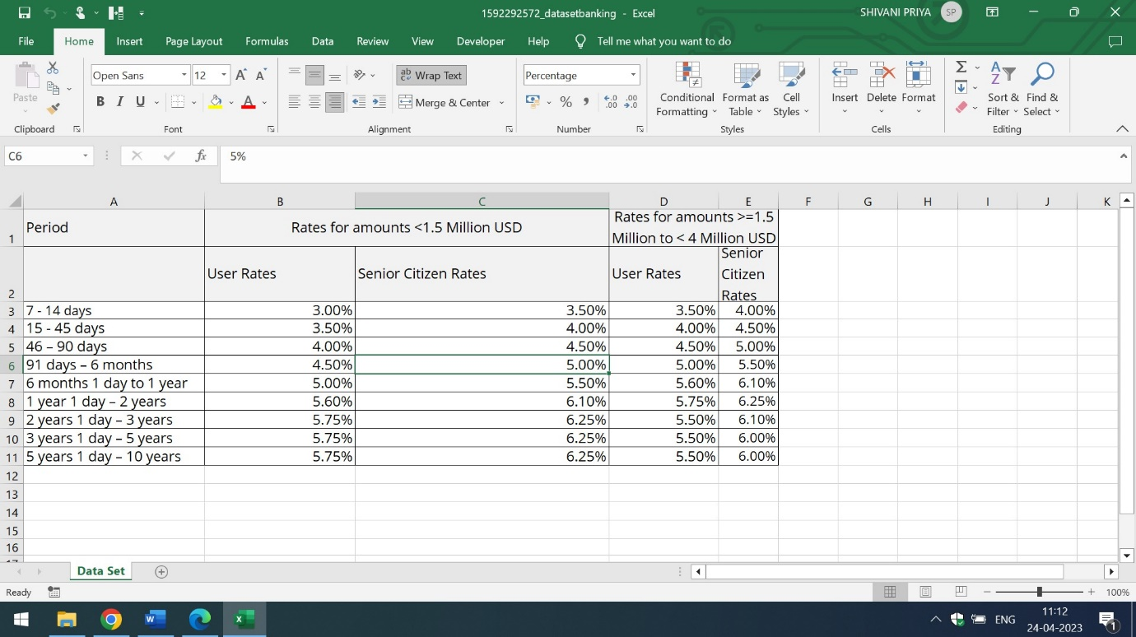

The rate applicable to all the Senior Citizens who are 60 years of age and above will be 0.50% above the applicable rate.

1. There should be one Fixed Deposit Calculator tab which must be present inside the View Reports and Sign Out page where the customer enters the age and the amount of FD Creation. The FD calculator displays the maturity amount
2. If the customer has multiple bank account options,there has to be an option of selecting the account to debit for FD and it must be linked with the online Bank FD creation page and the rates of the FD page
3. There must be a separate column of Joint Fixed Deposit where the customers have an option to enter a nominee
4. When the customer clicks on the Joint FD,a detailed information of Total Limit Required,Total Available Balance,Account Number and FD Number and Available Amount has to be visible
5. There has to be a separate tab of Download PDF which must be present inside the FD Amount Tab
6. When the customer clicks on Download PDF, they get an email notification for the PDF copy of FD,must be able to download the PDF in their system and gets the notification of the PDF copy in online banking and in mobile banking account
7. There has to be separate column of the view reports which is visible to ABC Bank Management only
8. When the ABC Bank Management clicks on view reports,they must get notified through reports of

-Total value of FDs for users with tenor of less than 6 months.

-Total value of FDs for senior citizens with tenor of less than 6 months.

- Total value of FDs for users with tenor of between 6 months 1 day and 1 year.

- Total value of FDs for senior citizens with tenor of between 6 months 1 day and 1 year.

- Number of FDs that are more than 1.5 Million USD for normal users.

- Number of FDs that are more than 1.5 Million USD for senior citizen users.

Q4) Write the in-scope and out-of-scope items for this software.

Ans) In-Scope requirements of the software are the requirements which lie inside the boundary While out-scope requirements of the software are the requirements which lie outside the boundary Some of the In-Scope and Out-Scope requirements are listed below:

**In-Scope Requirements:**

1. Only the customers of the ABC Bank Branches which has presence in 56 countries can use the online ABC Banking Website with E-Fixed Deposit
2. The web page of the ABC Bank Website must contains the three pages ie Login Page,My Accounts Page and View Reports page
3. The login page has the User-Interface of accepting the existing and new customers credentials, The My Accounts Page has the My Accounts tab which displays the Total Balance,Credit Card Types,Loan Types and E-Fixed Deposits in Banking Account and Mobile App and The View Reports Page has separate tab and columns of online FD Creation,Joint FD Creation with nominee option , Download PDF Tab which is accessible to all customers of ABC Bank and the last one is View Reports Tab which is visible to only ABC Bank Management
4. The sign out option must be present at the last section of the View Reports tab so that the customers and the ABC Bank Management can sign out successfully

**Out -of -Scope Requirements:**

1. Only the citizens of the 56 Countries where the ABC Bank has their presence and branches can use the automated ABC Banking Website with e-fixed deposit. If any other citizen apart from these 56 Countries are using the ABC Bank Website then it comes under Out-of Scope Requirement
2. If the employees of any alternate bank are using the ABC Bank Website with E-Fixed Deposit,then it also comes under Out-of Scope Requirement. Only the ABC Bank employees have permission to use the ABC Bank Website
3. If any alternate Bank Management are viewing the reports inside the ABC Bank Website with E-Fixed Deposit then it is also a part of Out-of scope requirements. Only the ABC Bank Management have permission to view the reports in View Reports Tab of ABC Bank Website
4. Only the Saving Account with ABC Bank is required for online FD Creation. If Current Accounts,Demat Account are used for opening an online FD then it is categorized under Out-of Scope Requirements
5. If the Fixed Deposit Calculator is asking for Customer’s Address, Customer’s City or Date-of Birth related information then it is also viewed as Out of Scope Requirement of the Software. FD calculator only asks for the customers age and the amount he/she wants to create an FD for. The FD calculator will display the maturity amount.

Q5) Write out the business requirements, both functional and non-functional requirements.

Ans) **Functional Requirements**: are the requirements which must be present in the product. These are the functions which developer must enable to accomplish their tasks Some of the functional requirements of automated Bank Website with e-fixed deposit are listed below:

1. The home page of the automated Bank Website must contains the label of username and password. The textboxes must be assigned to username and password fields and there has to be one submit and reset button for capturing and erasing the user details from the assigned textboxes.When the user clicks on the submit button,the accounts tab must appears on the top of the page in the software
2. When the user clicks on Accounts Tab, a detailed drop down should appear which contains the Account Summary,Credit Cards list,loan types and e fixed deposit options in the drop down view
3. On Clicking the Accounts Summary it must display the Total Balance, there has to be one option of hiding the balance also.When the Customer clicks on Credit Cards the various types of Credit cards such as Travel,Fuel,Rewards,Shopping,Business and Student has to be visible in the options format.
4. On Clicking the Loan type,the various types of loans such as Home,Gold,Student and Vehicle should be visible to the customer
5. The last option is of e-fixed deposit which is present at the last section of the My Accounts Page
6. The last page is of View Reports and Sign Out Page.There has to be a separate column of online FD Creation.When the Customer clicks on the online FD,it must display the two rows in the slide show fashion. The first row displays the requirements for opening an Online ABC Bank FD which includes the information of the saving Account,An Online Banking Account and the mobile Banking Account while the second row gives information about the FD rates in the below mentioned tabular format:



1. View Reports and Sign out page of ABC Bank shall have one separate tab of Fixed Deposit Calculator. When the user clicks on Fixed Deposit Calculator, a detailed drop down must appear in front of user which contains the two labels and two text boxes. The name of first label is to enter the customer age and the second one is amount for FD Creation. The two text boxes must be placed in front of these two labels and has to be white in color. There has to one button which is labelled as FD Calculation. When the customer clicks on FD Calculation, it must display the Maturity amount to the user
2. There has to be a separate column of Joint FDs which is present at the right side of the Fixed Deposit Calculator. When the Customer clicks on the Fixed Deposit Calculator,it must display the name of nominee if the nominee is registered. If the nominee is unregistered, it shall ask for the nominee name
3. There has to be a separate tab of Total FD Amount. When the user clicks on the Total FD Amount,it must display the total limit required,Total Available Balance,Account Number as well as FD Number and Available Amount
4. The Download PDF Tab must be present below the FD Amount Tab. When the customer clicks on the download pdf, they get an email notification for the PDF copy of FD,they must be able to download the PDF in their system and gets the notification of the PDF copy in online banking and in mobile banking account
5. The second last column is of the view reports which is visible to the ABC Management only so that get notified through reports of

-Total value of FDs for users with tenor of less than 6 months.

-Total value of FDs for senior citizens with tenor of less than 6 months.

- Total value of FDs for users with tenor of between 6 months 1 day and 1 year.

- Total value of FDs for senior citizens with tenor of between 6 months 1 day and 1 year.

- Number of FDs that are more than 1.5 Million USD for normal users.

- Number of FDs that are more than 1.5 Million USD for senior citizen users.

q) The last column is of sign-out. When the user clicks on sign-out,they must be able to successfully sign out from the ABC Bank Website

**Non-Functional Requirements:** are the qualities of the system.These are the quality attributes.These are basically the support features. Some of the Non-Functional requirements are:

1. **Availability:** The automated Bank Website along with E-Fixed Deposit is available for ABC Bank Employees and Customers which has presence in 56 countries in the world
2. **Compatibility**: The software must handle the registration of ABC customers of 56 countries
3. **Usability**: The software is easy to use for ABC Bank employees and customers
4. **Security:** The automated Bank Website along with E-Fixed Deposit can handle threats,viruses and malicious attacks
5. **Localization:** The user interface of the software is designed in English language and the rates of the FD are mentioned in USD
6. **Extensibility:** The software can incorporate new features according to Stakeholders requirements
7. **Compliance:** Only the ABC Bank Management,ABC Bank employees and the customers of 56 countries of ABC Bank Branches have access of ABC Bank Website. If any alternate Management of Bank and employee or customers try to login in ABC Website it will show the authentication error and wont accept the credentials
8. **Portability:** The ABC Bank employees of 56 countries can access the automated software on every desks. It must be portable and handy

Q6) Draw wireframes or mock screens for any two of the features. Use the technique prototyping or wireframing that is taught in the training. You can use any of the wireframing tools like Microsoft PowerPoint, Microsoft Word, Balsamiq, Sketch, Adobe XD, Adobe ILLustrator, Figma, UXPin, InVision Studio, Invision Freehand, or Moqups.

Ans) The wireframe of the accounts overview of Automated ABC Bank Website with E-Fixed Deposit is mentioned below:

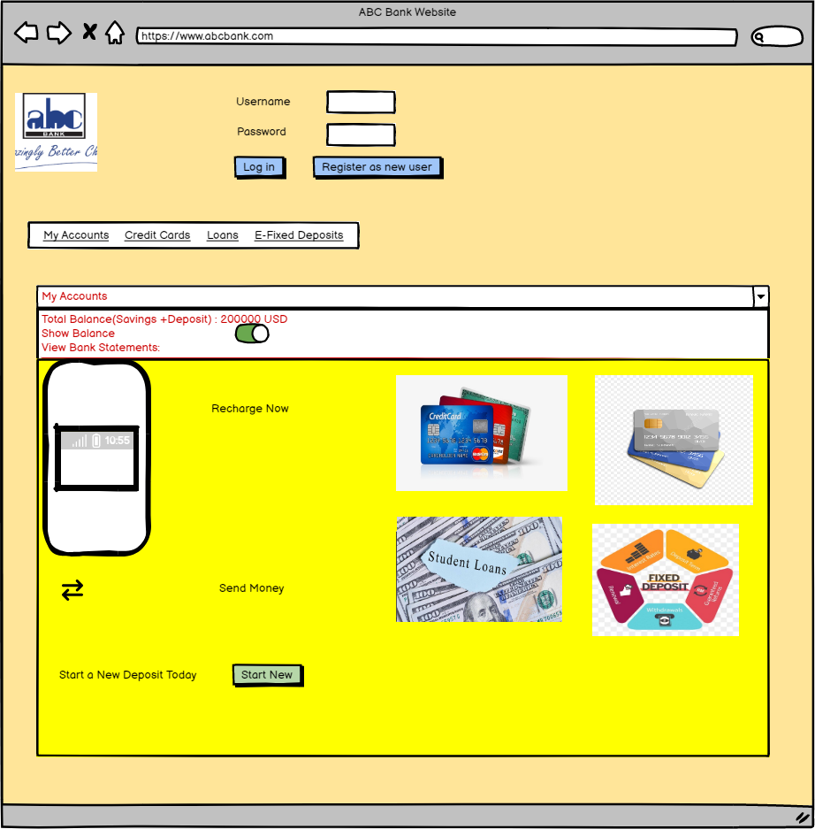

The wireframe of E-Fixed Deposit without Joint FD is mentioned below:

